- Reaction condition(s) and Mechanism? Draw the transition state and rational the diastereoselectivity~

- Draw the Mechanism?
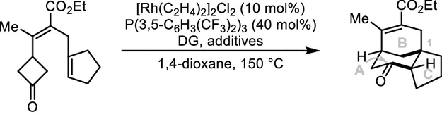

- Draw the intermediates and rational the diastereoselectivity~?

- Mechanism and Complete the catalytic cycle？

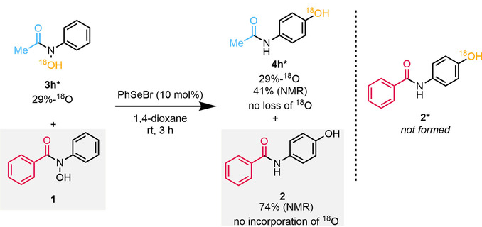

- Complete the scheme, draw the details

- Reaction condition(s) and Mechanism?

- draw the mechanism details

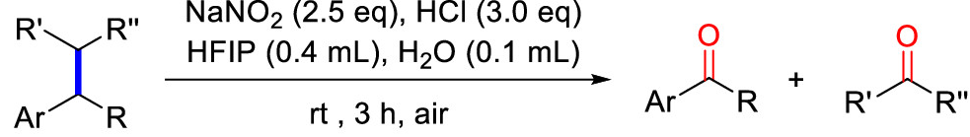

- Rational the chemoselectivity
