- Reaction Mechanism?
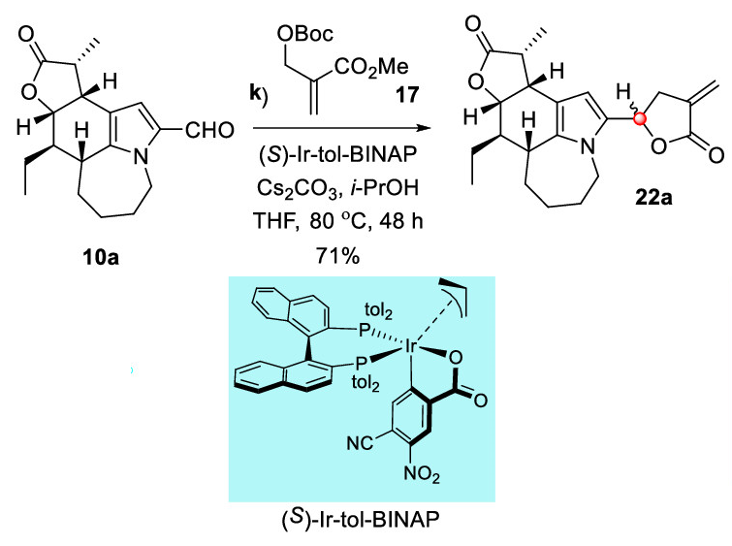

- Draw the details and intermediate

- Draw the details and intermediate

- Draw the Mechanism.
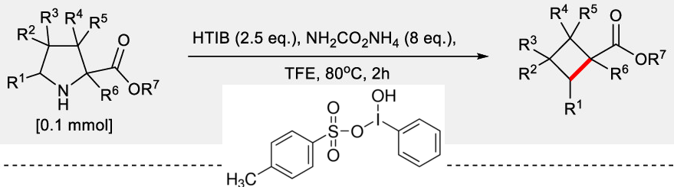

- Mechanism, draw the details

- Reaction details?

- draw the mechanism details

