- Mechanism, draw the mechanism：
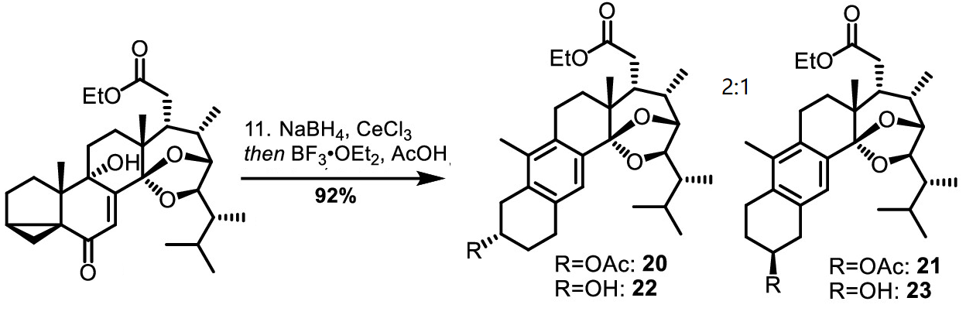

- Draw the mechanism details

- Mechanism, draw the details
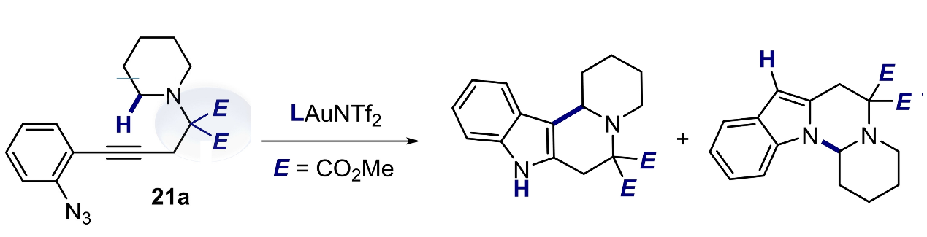

- Mechanism, draw the details. Indicating the role of every reagent

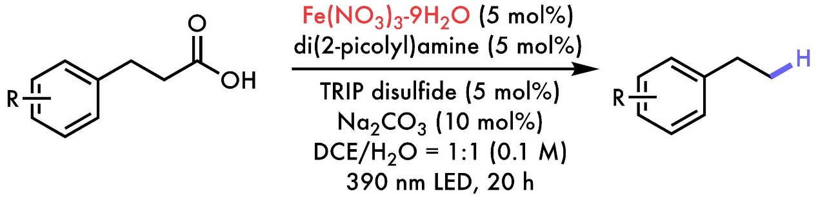

- Reaction Mechanism and details?
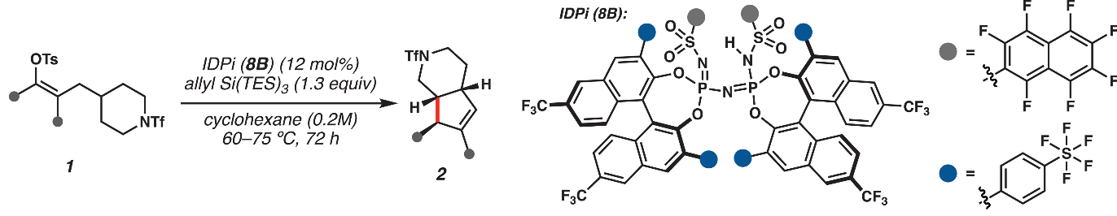

- Draw the details
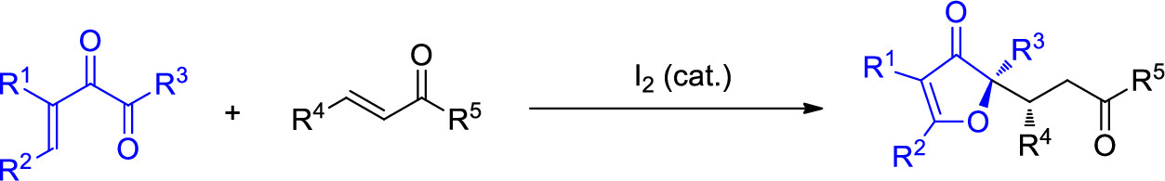

- Draw the details

