1. Mechanism, draw the mechanism：

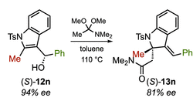

1. Draw the intermediate and mechanism details



1. Mechanism, draw the details



1. Mechanism, draw the details. 
2. Reaction Mechanism of each step?

