- Mechanism, draw the mechanism：

- Draw the intermediate and mechanism details(B048).

- Mechanism, draw the details.
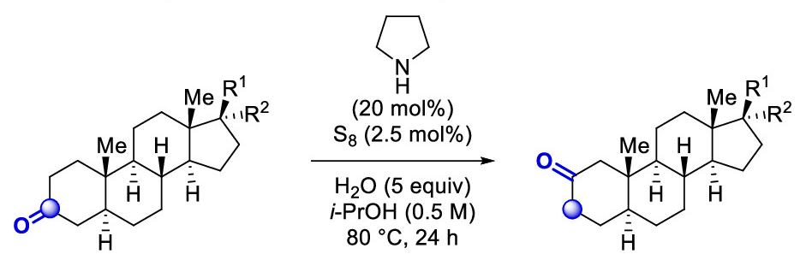

- Mechanism, draw the details.

- Reaction Mechanism of each step?

- Reaction Mechanism of each step?

- Reaction Mechanism of each step?

