1. Please propose a reasonable mechanism.

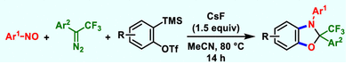

1. Please propose a reasonable mechanism.



1. Please propose a reasonable mechanism.



1. Please propose a reasonable mechanism.

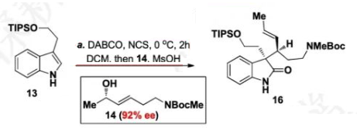

1. Please propose a reasonable mechanism.

