1. Please propose a reasonable mechanism.



2. Please propose a reasonable mechanism.



3. Please propose a reasonable mechanism.

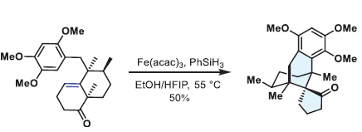

4. Please propose a reasonable mechanism.

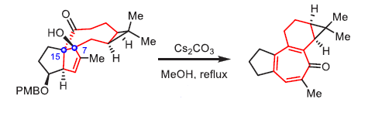

5. Please draw the intermediate.

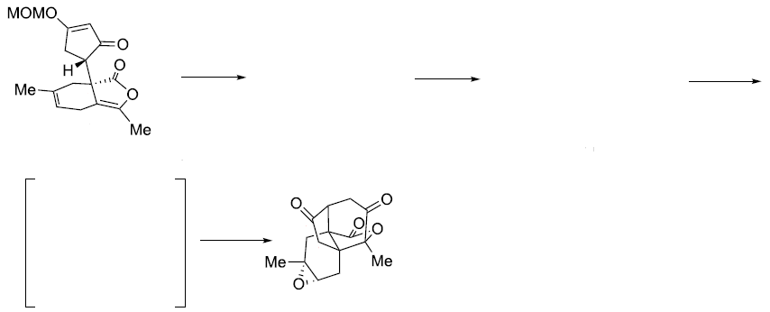

(i) Oxone (1.2 equiv), acetone/NaHCO3 (aq) (1.5:1), 0 °C;

(ii) *hν* (254 nm),MeCN, rt; then TMSBr (5.0 equiv), CH2Cl2, −78 to 0 °C, then MeOH (3.0 equiv);

(iii) DBU (3.0 equiv), MeCN, 0 °C, 62% (3 steps).